

TEAM 39 _ Industry Research

# Players

# Background

The Gig Economy is made up of three main components: the **independent workers** paid by the gig (i.e., a task or a project) as opposed to those workers who receive a salary or hourly wage; the **consumers** who need a specific service, for example, a ride to their next destination, or a particular item delivered; and the **companies** that connect the worker to the consumer in a direct manner, including app-based technology platforms. Companies such as **Uber, Airbnb, Lyft, Etsy** or **TaskRabbit** act as the medium through which the worker is connected to – and ultimately paid by – the consumer. These companies make it easier for workers to find a quick, temporary job (i.e., a gig), which can include any kind of work, from a musical performance to fixing a leaky faucet. One of the main differences between a gig and traditional work arrangements, however, is that a gig is a temporary work engagement, and the worker is paid only for that specific job.

The Gig Economy is by no means a new concept, but this past decade has seen it expand greatly. The share of the U.S. workforce in the gig economy rose from 10.1 percent in 2005 to 15.8 percent in 2015.[1] In 2016, 24 percent of Americans reported earning some money from the “digital platform economy” during the previous year (2015)[2]. The number of self-employed individuals (many of whom are independent workers in the gig economy) soared by over 19 percent from 2005 to 2015, with great variation across the country (See Map 1).[3]

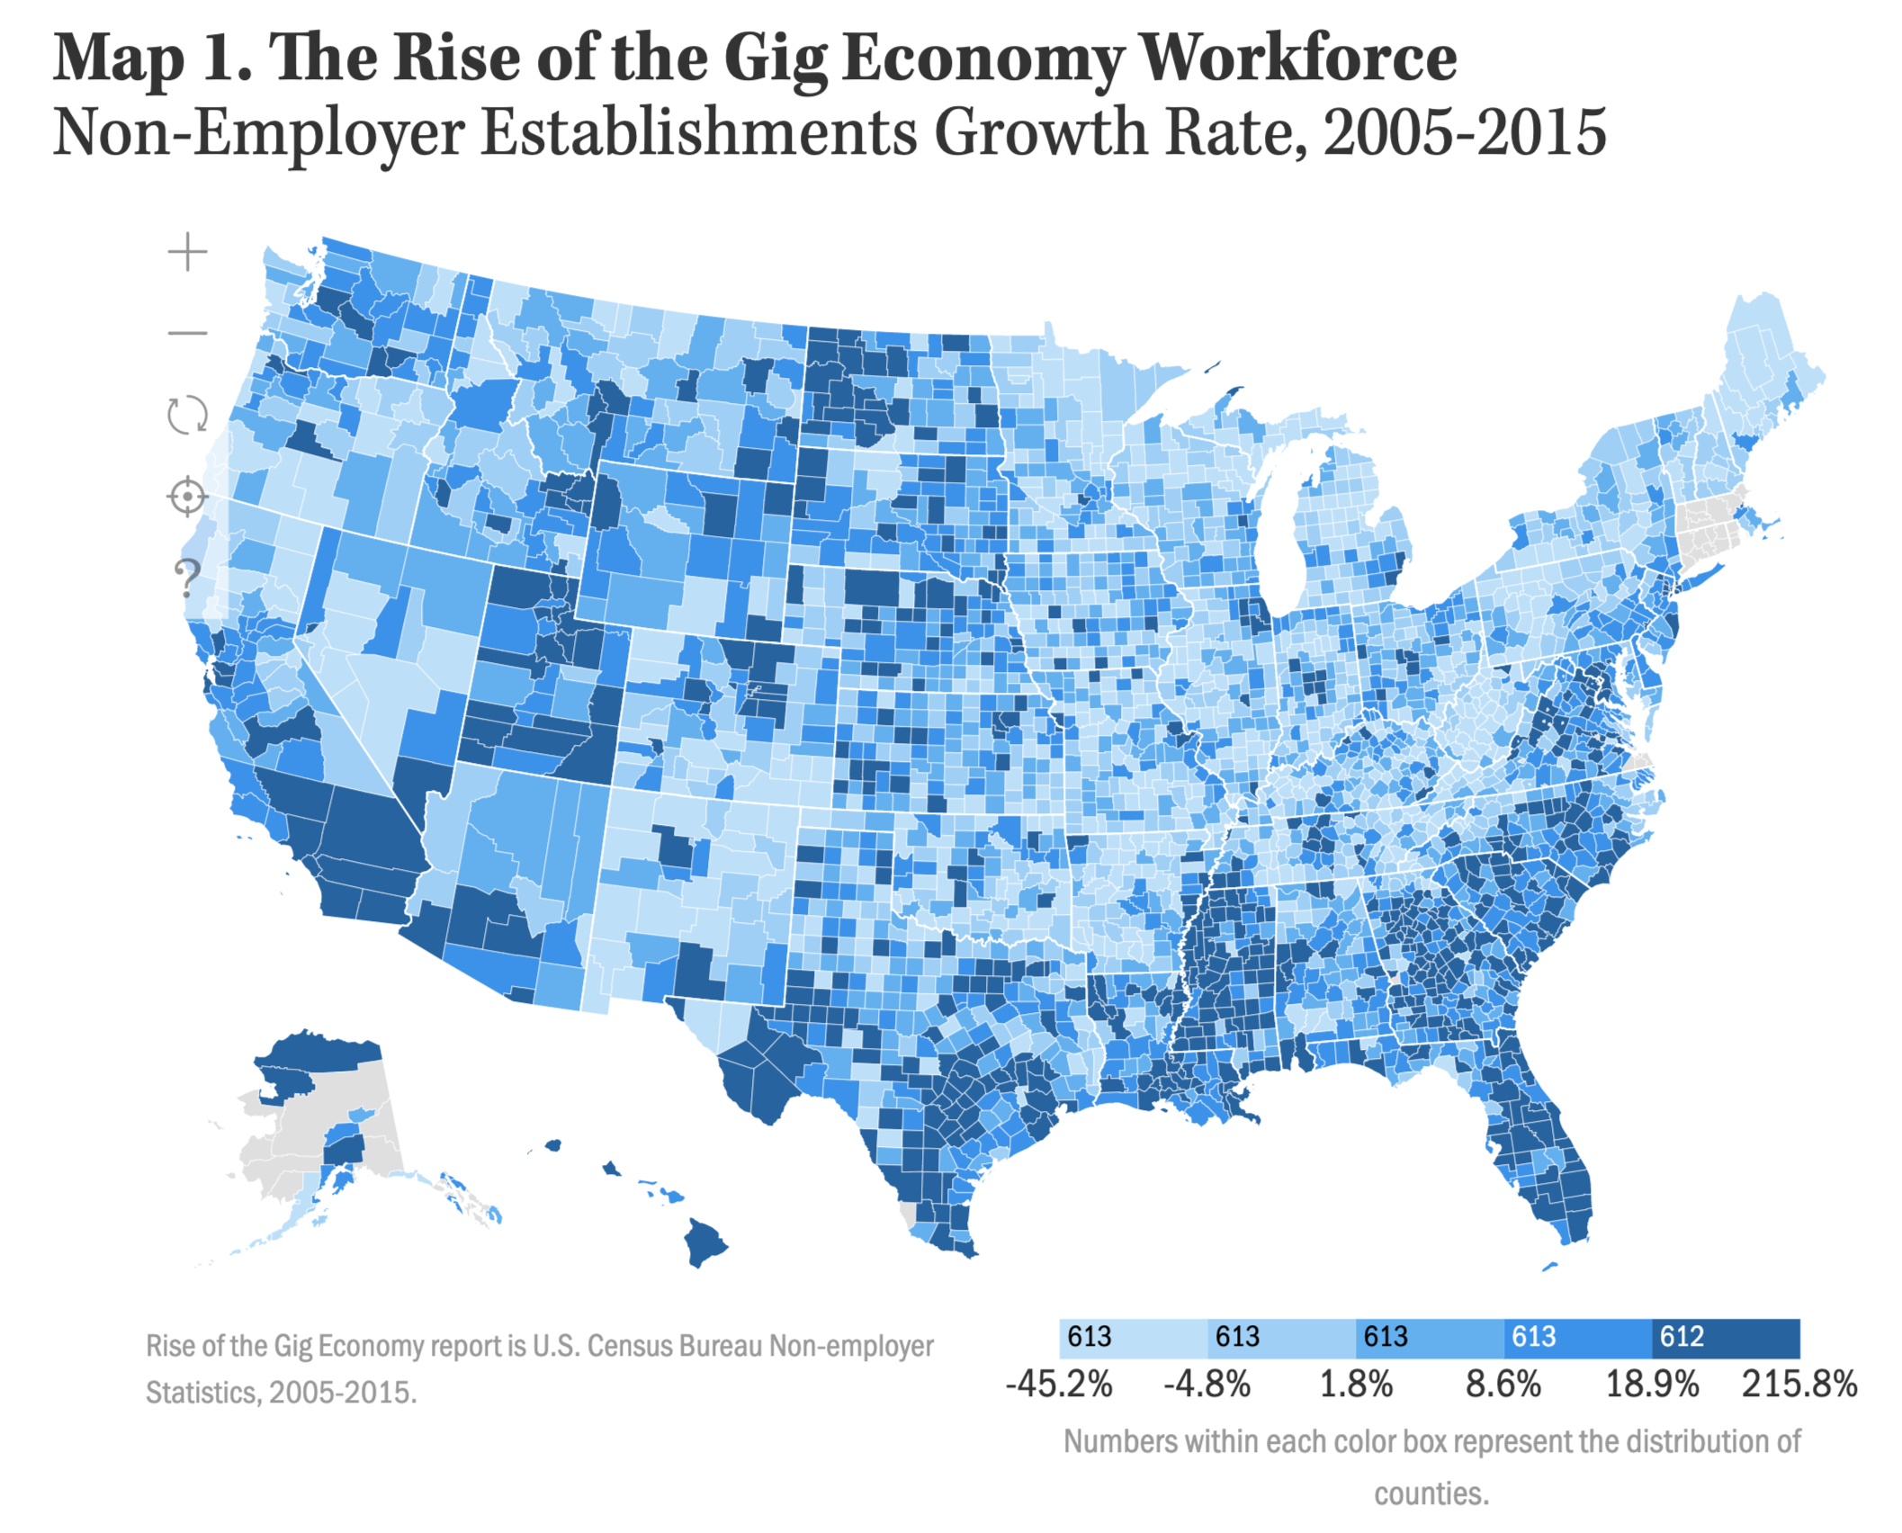

# Who are the main Players in the Gig Economy?

1. **Technology Platform Companies**

Technology platform companies have been a major force in the expansion of the gig economy. Included in this category are companies such as Uber, Lyft, Airbnb, Etsy, TaskRabbit and many more (see Gig Economy Honeycomb by Jeremiah Owyang[4] below)

These platform companies have a few distinct commonalities:

* 1. Facilitate direct transactions between consumer and producer/servicer.
  2. Flexible work schedules for gig workers.
  3. Online payments, from which platforms take a cut.
  4. Online profiles and reviews of both producers and consumers.

1. **Gig Workers**

Gig Workers can be classified into two broad categories:

* 1. Labor Providers
  2. For example: Handy-men, Driver, Delivery Me
  3. Goods Providers
  4. For Example: Craftsmen, Hosts, Artists

1. **Consumers**

Consumers can be described as people who use mobile platforms to book services or goods executed or provided by gig workers.

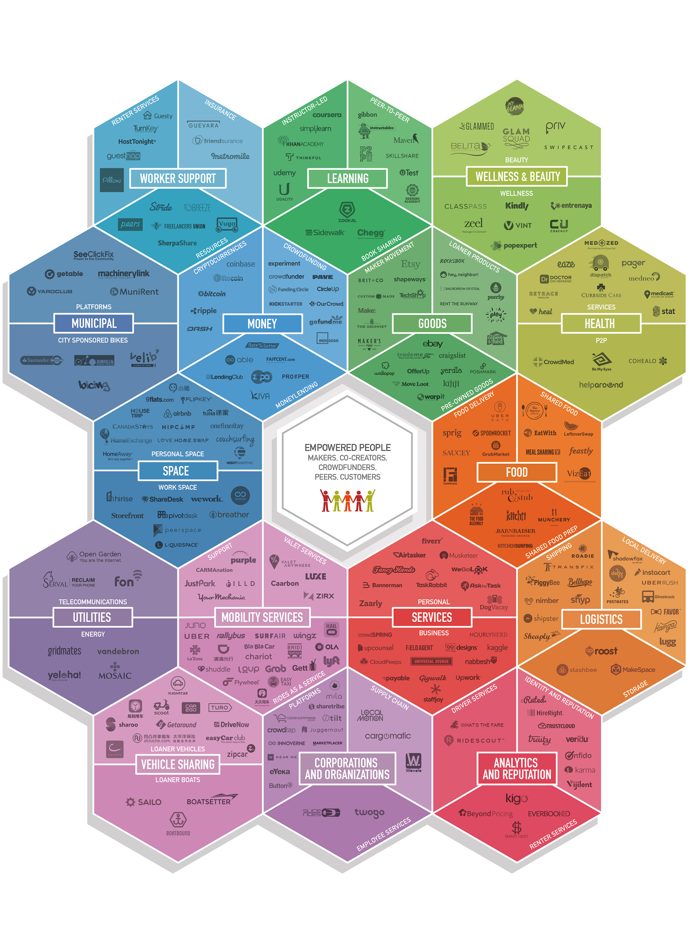

# Competitors

In the digital ecosystem of the Gig Economy, we have identified digital mobile and web services and platforms as our main competitors.

|  |  |  |  |  |
| --- | --- | --- | --- | --- |
| **Banking (All-In-One: Save, Invest, Borrow)** | **Money Management & Monitoring** | **Investment** | **Insurance** | **Other** |
| [M1 Finance](https://www.m1finance.com/) | [Personal Capital](https://www.personalcapital.com/) | [Robin Hood](https://robinhood.com/) | [Lemonade](https://www.lemonade.com/) | [Credit Sesame](https://www.creditsesame.com/) |
| [Wealthfront](https://www.wealthfront.com/) | [Mint](https://www.mint.com/) | [OpenInvest](https://www.openinvest.co/) | [Cover](https://cover.com/) | [CreditKarma](https://www.creditkarma.com/) |
| [Qapital](https://www.qapital.com/) | [YNAB](https://www.youneedabudget.com/) | [Vanguard](https://investor.vanguard.com/investing/) | [Trov](https://www.trov.com/) | [Quickbooks](https://quickbooks.intuit.com/self-employed/) |
| [Betterment](https://www.betterment.com/) | [CountAbout](https://countabout.com/) | [Ellevest](https://www.ellevest.com/) | [Brolly](https://heybrolly.com/) | [Wave](https://www.waveapps.com/) |
| [Stash App](https://www.stashinvest.com/) | [PocketSmith](https://www.pocketsmith.com/) | [FutureAdvisor](https://www.futureadvisor.com/) | [Simplesurance](https://www.simplesurance.com/de/) | [Other Tools](https://gigworker.com/must-have-tools-freelancers/) |
| [N26](https://n26.com/de-de) | [EveryDollar](https://www.everydollar.com/) | [Acorns](https://www.acorns.com/) | [Ladder](https://www.ladderlife.com/) | [Venmo](https://venmo.com/) |
| [Ally](https://www.ally.com/) | [Good Budget](https://goodbudget.com/) | [Wealthsimple](https://www.wealthsimple.com/en-us/) | [Fabric](https://meetfabric.com/) | [Zelle](https://www.zellepay.com/go/zelle) |
| [Chime](https://www.chimebank.com/) | [Status](https://statusmoney.com) | [Stockpile](https://www.stockpile.com/) | [Dinghy](https://getdinghy.com) | [SuperPay](https://superpay.it/) |
| [Simple](https://www.simple.com/) | [Moven](https://moven.com/) |  | [Wallace](https://wallace.co/?ref=producthunt) | [Payment Spring](https://paymentspring.com/) |
| [Monzo](https://monzo.com/) |  |  | [Blueprint](https://www.blueprintincome.com/) | [Earnin](https://www.earnin.com/) |
| [Dave](https://www.dave.com/) |  |  | [Zego](https://www.zego.com/) | [Brigit](https://hellobrigit.com/) |

# Profits (Values)

Technology and platform providers have been challenging the traditional economy and have been generating a new group of workers, known as “Gig Workers” or independent workers. Some studies indicate that there are between 54 and 68 millions of independent workers in the United States which are classified into four segments[5]:

1. Free agent: main income is from independent work, by choice.
2. Casual earner: independent work is a complement income, by choice.
3. Reluctant: their primary profit is from independent work, without choice.
4. Financially strapped: independent who works for supplemental income, without choice.

A gig worker is a person who provides temporary services for platform providers as an independent contractor for short-terms, on the idea of task-based labor. The usual example is the Uber drivers. Some proclaim that the possibility to work with more freedom allows gig workers to have more options, but others indicate that actually this new reality leaves workers with less options and also with more risks than any other independent contractor. In this line, it is said that “Gig workers are increasingly taking risks related not only to their labor but also to their own capital. This occurs when continued ownership of the assets used in work are dependent on a set of circumstances outside the control of the worker”[6].

# Metrics:

|  |  |
| --- | --- |
| **Concept** | **Approx. Quantities** |
| Amount of gig workers (2017) | 55 mill. |
| How many gig workers are in primary or supplementary work? | Over 1 in 4[7] |
| How many are gig workers with gig as a main job (independent work is primary)? | Around 1 in 10[8] |
| How many gig workers work via online platforms (Uber, Lyft and others)? | Fewer than 1 percent[9] |
| US workforce engaged in independent work arrangements | 26.9 %[10] |
| Expected gig workers (2020) | 43% of workforce |
| Wage growth (real terms) | Falls annually 0.5 – 1%[11] |
| Profit | FT earn more than $100.000 (nearly 20%)[12] |
| Opportunity to choose | 63% would choose to freelance[13]  74% would quit if they can work remotely more often |
| Millennials | 69% regret their job and preferred balance work/life |
| Compatibility between traditional jobs and remote work | 50% of the jobs are compatible[14] |
| Trust in gig economy for their main job | 10.1% of workers[15] |

# Economics: In this instance we will focus on Uber drivers.

Profits and costs of drivers are complex and variable depending on the time and the distance. Different factors might influence the income, such as: (i) offer and demand, (ii) whether the route is shared between many people who opt for pool services, (iii) bonuses and promotions that companies can provide, (iv) costs of the car, e.g.: rent a car or vehicle depreciation, insurance, maintenance, fuel, etc., (v) taxes, (vi) suppliers (services, e.g. tax advisor), (viii) tips.

There are multiple studies related to the profit for gig workers, based on diverse assumptions. Some show that the revenue for the drivers is represented in small numbers, others take averages for vehicles’ expenses, use estimates and calculate monthly profit. Also, there are studies that consider the price elasticity, the benefit for the consumer for buying a product for a cheaper price that they would be willing to pay for, and inefficiencies (e.g. long rides). Finally, to consider taxes some use the regular mileage deduction ($54 in 2016). [16]

However, none of these studies consider the drop in demand, the increase of competition in the market and the impact of additional miles. A Study made by MIT Center for Energy and Environmental Policy Research[17] considered the following operational costs:

1. Fuel: Considering fuel price, for each vehicle, also, that there was an increment in hybrid vehicles.
2. Insurance: A fixed cost which depends on the monthly miles.
3. Maintenance and repair costs: For new vehicles was nearly zero and increase with time.
4. Depreciation: Related to the age of the vehicle, the newest ones depreciate faster.

Furthermore, seemingly drivers might have other costs, e.g.: parking and taxes; and also is important to note that the 80% of the drivers work less than 40 hours per week. In conclusion, regarding the study above mentioned, drivers, per mile, approximately, have a median of:

|  |  |
| --- | --- |
| **Concept** | Median $/per mile |
| **Revenue** | $ 0,592 before expenses[18] |
| **Insurance, Maintenance and Repair costs** | $ 0.13 |
| **Depreciation costs** | $0 .05[19] |
| **Fuel** | between $ .05 and $ 0.27 |
| **Total Costs** | $ 0.3[20] (approx.) |
| **Profits before taxes** | $ 0.29 |
| **Standard mileage deduction** | $0.54 |

Taxes are significantly larger than the total costs, and 47% of drivers report fewer profits than the standard mileage deduction. Although they are earning as a median per month $ 309.7, with a taxable median income of $ 52.85. The median income per hour is $ 3.37/hour. In daily practice, some in their tax filed negate income, adding losses or using others nets. Approximately 30% of the drivers are failing to earn profit per mile.[21]

Participation Sets

The gig economy is part of a shifting cultural and business environment that also includes the sharing economy (digital platform based services), the gift economy (intangible rewards based) and the barter economy. Digitization of modern world has given a significant boost to millenials who favor a better work life balance and are opting for part-time work (largest section of gig economy). While non-digital segments like small businesses, temporary services, wholesalers and resellers, also contribute to the gig economy, they are excluded for the purpose of this study as their relative Gross Volume compared to digital services is small.

The size of Gig Economy transactions is projected to grow by a 17% CAGR with a Gross Volume of ~$455B by 2023 from ~$204[22]B in 2018, due to factors such as evolving societal attitudes around P2P sharing and increasing digitization rates in developing countries. US comprises of 44% share of this gross volume.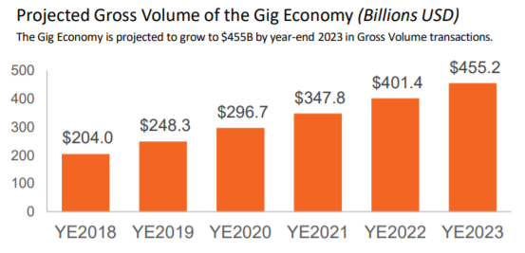

# 

# 

# 

# 

# Sectors

The Gig Economy can be broken down into four “sectors” that describe the type of services a freelancer provides. The sectors’ contribution to the overall size of the Gig Economy varies, with Transportation-Based Services boasting a significant lead in generating the greatest share of GV – 57.8%, or $117B. Comparatively, the Asset-Sharing sector – notably smaller than Transportation Services at $62B – is the second largest contributor, leading Professional Services and HGHM by a significant margin.

**Transportation-Based Services**: The lucrative performance of this sector compared to the others can be explained by the ubiquity of ride-sharing globally – from major platforms in North America such as Uber and Lyft to those in Asia Pacific such as Grab, Go-Jek and Ola.   
**Asset-Sharing Services**: Though major Asset-Sharing platforms as a whole offer significantly fewer hosts than Transportation platforms do drivers, the Asset-Sharing sector generates 30.3% of Gig Economy GV due to its ticket size per home rental (e.g., Airbnb, TripAdvisor Rentals).  
**Professional Services**: This sector generates the smallest share of Gig GV at $7.7B.

The growth in Gig Economy is anticipated to remain positive but variable across regions. US is expected to continue its lead but developing regions will demonstrate greater contribution. India is projected to grow by 115% by 2023, and Brazil by 129%[23]. In contrast, France, being a more mature Gig market is estimated to grow its GV only by 68% through 2023.

# 

# 

# 

# 

# 

# 

# 

# Business Model

The below diagram represents Airbnb’s business model which involves platform, owner (gig worker) and seeker (customer). Though it is a simplified version of a specific transaction which involves Gig workers, the same principle can be generalized for other business models as well.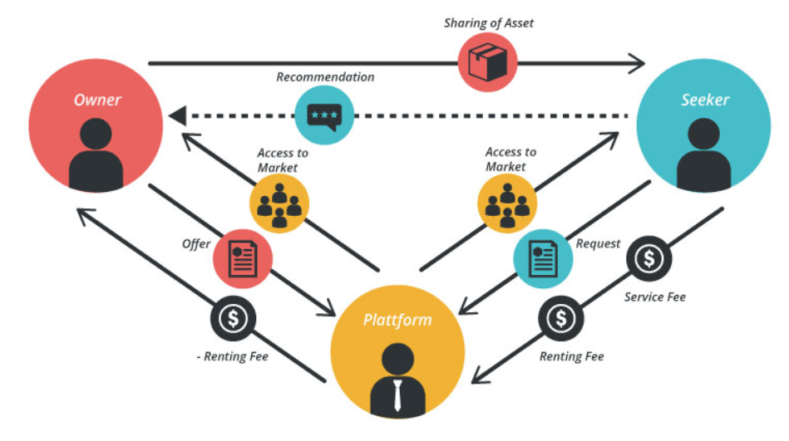

# Process

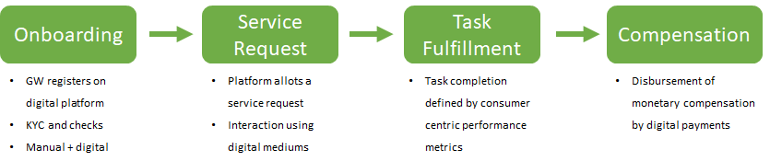

TEAM 39 _ Technology Research

# Background

There are many current forms of technology that make up the Gig Economy sphere and the financial apps that support it. The technologies that support this environment are heavily digital based and focus on connecting the two parties involved, namely the gig workers and the customers. Within each company in the Gig Economy space, there exists a typical framework of technology that is utilized to match workers and customers. These technologies directly support the interfaces that the gig workers interact with through their work devices, usually smartphones and tablets. The chart below displays a summary of other functions that happen on the backend to power Uber’s application[24]. Among the more important features that are common to all Gig Economy companies include geolocation, matching algorithms, and dynamic pricing models. It is of note that Uber is being used as an example because it occupies a majority of the gig worker market share in terms of daily users.

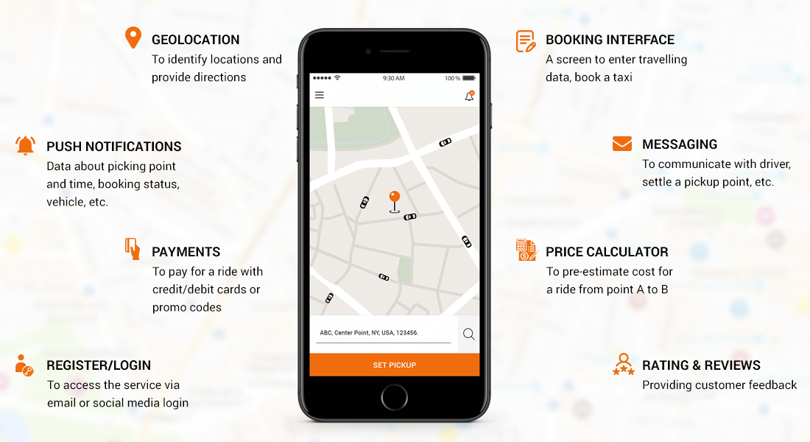

# Geolocation

One of the most important technology features that applications in the gig economy use is geolocation. This technology allows for the mapping of providers and customers based on inter relational distance. As an important point of gig worker functionality lies in optimized matching and service, minimizing travel distance between matches is a key advantage of company offerings. Uber utilizes Apple’s Core Location framework as well as Google’s Location API and Google Maps’ API to develop their location functionality[25].

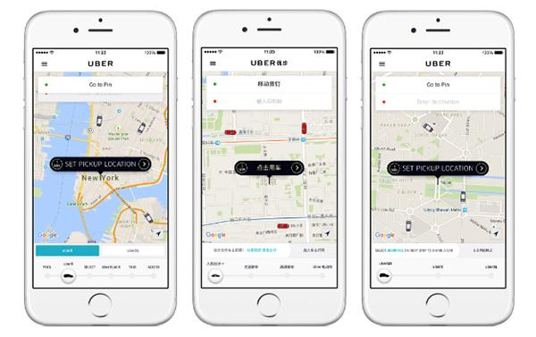

# Matching

The operations within the gig economy rely heavily on the matching algorithms that each company develops. These algorithms range from automated matching to manual matching and drive the value proposition and differentiation of many of these companies. Uber utilizes a batch matching algorithm that aggregates user requests to process in batches, resulting in lower overall wait times for groups as a whole. Lyft utilizes what they call Route Swapping and Matching Exchange that operates on similar principles, by waiting 30 second intervals before matching to provide more efficient pickups[26]. Companies like TaskRabbit allow customers to manually match in order to select custom services based on quality and price point.

# Pricing

The Pricing technologies that these companies implement allow for the gig workers to have streamlined, unabated access to their funds. One of the main benefits of gig working is the ability to cash out money earned immediately. To facilitate this, companies use a variety of tools to establish a pipeline between their payout services to user financial institutions. These include the ability to link checking accounts, utilizing PayPal credit card image capture, and integrating tools such as BrainTree, a PayPal service that facilitates mobile payment structure.

Appendix

# Business Model Canvas

|  |  |  |  |  |  |
| --- | --- | --- | --- | --- | --- |
| ***Key Partners*** | ***Key Activities*** | ***Value Proposition*** | | ***Customer Relationships*** | ***Customer Segments*** |
| Technology Platform Companies  Investment Banks  Money Management & Monitoring Platforms  Insurance Companies  Government Institutions | Our Key Activities include :  User Research - Tapping major chunk of the gig work-force to get a ballpark figure of the financials we are dealing with.  Industry Research and eventual Design Research  Building/Development Phase  Final Prototype | How might we improve the financial lives of gig workers so that they are financially healthy and more resilient to shocks? The bundles of products and services we would be creating and offering to our Customer Segment would essentially answer the aforementioned question. | | The relationship Customer Segment would expect us to establish and maintain with them would be understanding, given the sensitivity of the Product Challenge. Empathy is a crucial element for integrating and establishing the Customer Relationships. | Side Gigs  Career Freelancers  Substitutes  Business Builders |
|  | ***Key Resources*** |  | | ***Channels*** |  |
|  | BMG  Our Industry and Technology Research |  | | Our Communication Channels with our Customer Segment would vastly rely on our end product or prototype. Currently, we are reaching them on ground for our user research data. We will come up with a co-efficient channel soon. |  |
| ***Cost Structure*** | | | ***Revenues Streams*** | | |
| NA | | | NA | | |

1. ### Lawrence Katz and Alan Krueger, “The Rise and Nature of Alternative Work Arrangements in the United States, 1995-2015,” NBER Working Paper No. 22667, September 2016.

  
2. ### Aaron Smith, “Gig Work, Online Selling and Home Sharing,” Pew Research Center, November 2016.

  
3. ### NACo analysis of U.S. Census Bureau data, 2005 and 2015.

  
4. ### Jeremiah Owyang, Web Strategist, 2016 <http://www.web-strategist.com/blog/2016/03/10/honeycomb-3-0-the-collaborative-economy-market-expansion-sxsw/>

  
5. ### McKinsey: “Independent work: choice, necessity, and the Gig Economy”. URL: <https://www.mckinsey.com/~/media/McKinsey/Featured%20Insights/Employment%20and%20Growth/Independent%20work%20Choice%20necessity%20and%20the%20gig%20economy/Independent-Work-Choice-necessity-and-the-gig-economy-Executive-Summary.ashx>

  
6. ### VINCENT JELANI, URL: [https://scholar.harvard.edu/vincentjelani/publications/‘’gig”-economy-workers-taking-more-risk#targetText=Gig%20workers%20are%20increasingly%20taking,the%20control%20of%20the%20worker.](https://scholar.harvard.edu/vincentjelani/publications/%E2%80%98%E2%80%99gig%E2%80%9D-economy-workers-taking-more-risk#targetText=Gig%20workers%20are%20increasingly%20taking,the%20control%20of%20the%20worker.)

  
7. ### Gig Economy, Data Hub. URL: <https://www.gigeconomydata.org/basics/how-many-gig-workers-are-there>

  
8. ### Ibidem.

  
9. ### Ibidem

  
10. ### Ibidem, reference to MBO Partners, “The State of Independence in America”(Herno , VA: 2018), <http://www.mbopartners.com/state-of-independe>

   
11. ### Anat Bracha and Mary A. Burke, senior economists at the Boston Fed. URL: <https://www.axios.com/gig-economy-employment-economic-data-effect-d8ef97ff-1774-4223-9fd8-d50510fb3c9f.html>

   
12. ### The Wiley Professionals, URL: <https://www.wiley.com/network/professionals/business-trends/10-facts-about-the-gig-economy>

   
13. ### Ibidem

   
14. ### Ibidem

   
15. ### Gig Economy, URL: <https://www.gigeconomydata.org/basics/how-many-gig-workers-are-there>

   
16. ### Preston 2017, Singer-Vine and O’Donovan 2016, Earnest 2017, Hall et al 2017, Castillo et al 2017: all referenced in “The Economics of Ride-Hailing: Driver Revenue, Expenses and Taxes” by Zoepf, Stephen and others, from Center for Automotive Research at Stanford, Stanford University Graduate School of Business. URL: <https://orfe.princeton.edu/~alaink/SmartDrivingCars/PDFs/Zoepf_The%20Economics%20of%20RideHialing_OriginalPdfFeb2018.pdf>

   
17. ### Ibídem

   
18. ### Vary, but infrequently more than $ 1.00/mile.

   
19. ### Closely 90% have depreciation costs fewer than $0.10/mile

   
20. ### A minor exceed % .50/mile.

   
21. ### Preston 2017, Singer-Vine and O’Donovan 2016, Earnest 2017, Hall et al 2017, Castillo et al 2017: all referenced in “The Economics of Ride-Hailing: Driver Revenue, Expenses and Taxes” by Zoepf, Stephen and others, from Center for Automotive Research at Stanford, Stanford University Graduate School of Business. URL: <https://orfe.princeton.edu/~alaink/SmartDrivingCars/PDFs/Zoepf_The%20Economics%20of%20RideHialing_OriginalPdfFeb2018.pdf>

   
22. *Sources -*[*Mastercard Gig Economy Industry Outlook and Needs Assessment*](https://newsroom.mastercard.com/wp-content/uploads/2019/05/Gig-Economy-White-Paper-May-2019.pdf)

    [*Data on the Gig Economy and How it is Transforming the Workforce*](https://www.wonolo.com/blog/data-gig-economy-transforming-workforce/)

    [*GIG ECONOMY: STATISTICS, FACTS & MAIN PLAYERS*](https://apiumhub.com/tech-blog-barcelona/gig-economy/)
23. *Sources -*[*Mastercard Gig Economy Industry Outlook and Needs Assessment*](https://newsroom.mastercard.com/wp-content/uploads/2019/05/Gig-Economy-White-Paper-May-2019.pdf)

    [*Data on the Gig Economy and How it is Transforming the Workforce*](https://www.wonolo.com/blog/data-gig-economy-transforming-workforce/)

    [*GIG ECONOMY: STATISTICS, FACTS & MAIN PLAYERS*](https://apiumhub.com/tech-blog-barcelona/gig-economy/)
24. <https://www.bacancytechnology.com/blog/technology-stack-behind-the-grandeur-success-of-uber>
25. <https://eng.uber.com/tech-stack-part-one/>
26. <https://eng.lyft.com/matchmaking-in-lyft-line-part-3-d8f9497c0e51>